Title of the Manuscript
Author Full Name^{1,}*, Author Full Name² and Author Full Name³
Web of Science Researcher ID:
ORCID ID:
All the manuscripts must be accompanied by an abstract. In brief, the abstract should concisely describe the purpose of the research, indicate the experimental procedures used, summarize the key findings, and focus on the major conclusions. Abstract should be in one paragraph and maximum 200 words.

Introduction
A detailed introduction is required here with proper emphasis on: (i) Importance of the addressed subject in general, (ii) importance of addressed subject in particular, (iii) related aspects covered in the literature, (iv) at the end, a clear description of what is unique about the present work (what is new here or how it differs from the previous works). It must be written in such a way that the readers can get a detailed overview about the addressed subject (past, present, and future perspectives and challenges). References should be listed as: [1] wherever needed.
Introduction can be up to 1000 words (but this is not the absolute limit).

Experimental
Provide appropriate experimental details in this section in form of subsections:

Materials/ chemicals details
Material synthesis / reactions
Characterizations / device fabrications /response measurements

Results and discussion
Discuss all the results and corresponding discussions in this section. Make sure that proper coherency is maintained, and appropriate discussions are included.
____________________________________________________________________________________________
¹Author-affiliation: Department Name, Institute, University, Street address, city, postal code, country
²Author-affiliation: Department Name, Institute, University, Street address, city, postal code, country
³Author-affiliation: Department Name, Institute, University, Street address, city, postal code, country

*Corresponding author:
E-mail: Tel.:
DOI: 10.5185/amlett.2022.XXXXXX

Authors are especially encouraged to include attractive graphics, schematic designs for material importance/synthesis method/growth model/device concept/involved, physical and mechanisms/material modification, etc. (whatever suits well with respect to the addressed subject in the manuscript).
Fig. XX can be directly inserted with the running text at relevant places (they can also be given at the end, after the references in the order of figure number, figure and a caption, one figure on one page).
A maximum of 6 figures (including schematics) is allowed. Each figure can be combined with multiple figures in form of a, b, c, d……. (In an exceptional case, 7 figures would be fine).
Remaining figures can be given in the supplementary information file as additional supporting data (which will be freely available on the journals website). The supplementary info figures must be appropriately indexed in the text at the relevant places in the main manuscript.
A maximum of two tables are allowed and authors must choose only those tables for the main manuscript which deliver main and the most important information. The remaining tables must be included in the supplementary information.
Make sure that good quality figures with clear: (i) key messages, (ii) levels/font sizes, (iii) scales, (iv) color contrasts, (v) line widths/symbol sizes are used (qualifying this criterion is mandatory for manuscript publication irrespective of referee comments).
If the authors plan on using any figure which is already published, they must get copyright permission from the respective publishers/copyright holders
Use chemdraw to insert chemical formula.
Use mathtype to insert mathematical formula/equations

Conclusion
Appropriate conclusion should be written here which reflects the exact finding demonstrated in the paper. The conclusion section must also highlight the future prospects of the present work.

Acknowledgements
The acknowledgements come at the end of an article after the conclusions. Please add here the funding agencies and other acknowledgements.

Conflicts of interest
Please ensure that a conflict of interest statement is included in your manuscript here. Please note that this statement is required for all submitted manuscripts. If no conflicts exist, please state that “There are no conflicts to declare”.

Keywords (Keywords should be 3-5 and separated by a comma)
Keyword 1, Keyword 2, Keyword 3, Keyword 4.

Supporting information
Supporting informations are available online at journal website.

References
(follow reference style as below, journal abbreviation must be taken from Chemical Abstract Service, CAS database).

(a) Scientific article
- Liu, M.; Castilho, C. J.; Hurt, R. H.; Adv. Mater. Lett., 2018, 9, 843.

(b) Book
2. Tiwari, A. (Ed.); Graphene Bioelectronics; Elsevier, Oxford, UK, 2018.

(c) Book Chapter
3. Gottlieb, R.; Poges, S.; Monteleone, C.; Suib, S.L. Contnious Fiber-reinforced ceramic matrix composites; Tiwari, A.; Gerhardt, A.R.; Szutkowska, M. (Eds.); Wiley: USA, 2016, pp. 147-200.

(d) Patent
4. Fokin, V.; Finn, M. G.; Sharpless, K. B. U.S. Patent 0311412 A1, 2008.

(e) Meeting/Conference/Symposium Abstract:
5. Larcher, D. Abstracts of Paper, Session S2: Lithium-ion Batteries, Symposium S, Mater. Res. Soc. Symp. Proc. 822, Warrendale, PA, Vol. 822, 2004.

SUPPORTING INFORMATION

Include all the supporting information data here like
- Experimental setups/ Schematics
- Chamical formulas/ Theoretical calculations
- Digital photographs/ Figures/ Videos
- Tables/ Other evidences
- ……

Authors Biography

(Please add all the authors’ biography at the end of the manuscript. The biograpgy text must not exceed 75 words. Please find a sample below)

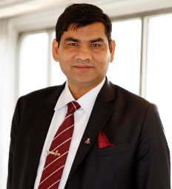
Prof. Ashutosh Tiwari serves as a Chairman & Managing Director at the Institute of Advanced Materials, VBRI Group and Secretary-General of the International Association of Advanced Materials. He is a high-end professor and also has several honorary/ adjunct professor titles since 2009. Dr. Tiwari has been actively involved in translational research for building state-of-the-art technological systems to handle key challenges in medical, security, energy and environmental issues realized by the integration of artificial intelligence and smart strategies.

Format for figure
(label a and b should be placed in the upper left corner) and ligand should be in font-Arial 8 size.

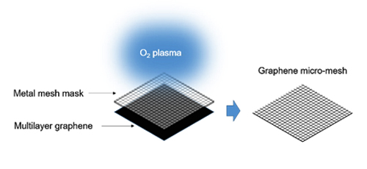 Scheme. 1. Schematic image of graphene micromesh fabrication process.

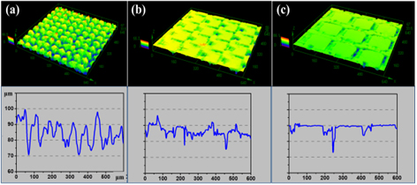

Graphical Abstract

Please make a brief schematic diagram as ‘Graphical Abstract’. Please make sure that this can clearly illustrate your work. All graphical abstract must also accompany with a synopsis of the graphic, the synopsis text must not exceed 75 words.

